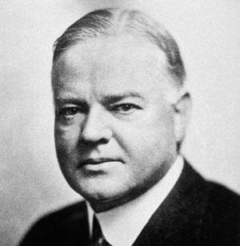

Herbert Hoover – President of the USA 1929 - 1932

